GA Design
This section describes the representation used to encode shapes, genes and chromosomes. The number of shapes to be cut, n, is constant throughout the course of the optimisation.

Shape Storage
There is exactly one n element array, called the shape group, which stores all shape specifications for cutting. One element in this array holds the specifications for a single shape:
- integer width (x_size)
- integer height (y_size)
- gene identifier (integer in range 0 to n-1)

The gene identifier uniquely labels each shape in the shape group.

Chromosome Representation
A chromosome has n genes. The specialised chromosome that has been defined is referred to as the LDA_chromosome, whose genes are called shape_genes. A single shape_gene contains two data items:

- a shape pointer – pointing to a single shape in the shape group to be laid out.
- an orientation flag – boolean which signifies whether the shape is rotated 0 or 90 degrees.

An LDA_chromosome has exactly n shape_genes where each gene uniquely refers to a single shape in the shape group. The LDA_chromosome represents an ordered permutation of shapes, where each shape must be referenced exactly once. The orientation flag is set arbitrarily in each gene. Orientation is a property of the shape_gene rather than the shape itself. This allows a population of shape_genes to refer to a common shape group, whilst allowing individual shape_genes to modify their orientation property.

All LDA_chromosomes share a connection to the LDA_environment which contains the layout algorithms. This allows LDA_chromosomes to: evalutate their own fitness and initialise themselves to a random permutation or pre-determined permutation.

Selection Methods

Rank Selection
All candidates in the population have their fitness evaluated, and the population is ordered according to decreasing fitness. The first member of the ordered population (the fittest candidate) has n-times the probability of being selected than the least fit candidate, where n is the number of candidates in the population. The second-most fit candidate has (n-1)-times the probability of being selected than the least fit candidate, and so on for the rest of the population. The probability of the least fit candidate being selected is 1 / (1 + 2 + ... + (n-1) + n) = 1 / (n * (1+n) / 2).

Tournament Selection
A tournament may be held amongst m randomly picked candidates in the population. The tournament winner is the fittest candidate amongst those picked.

Heterogeneous Selection
One parent is selected at random. A randomly selected mate is picked, and if it is not too similar to the first parent, then all is done. If the second parent is too similar to the first, the selector has i chances to find a suitable parent, where i is just a limit such as 100. Similarity is measured using a distance function which counts the number of differences (eg in gene ordering) which are present between the two candidates.

Genetic Operators - Crossover
These operators take features from two parents to generate a child, whilst maintaining the permutation property of the chromosome.

Order-based Crossover
(Step 1) A random number of genes are chosen from parent 2 and the allele order is noted.
(Step 2) FOR all genes (i) in parent 1:
IF gene i in parent 1 contains an allele which isn’t in one of the chosen genes
copy the allele in gene i of parent 1 to gene i of the child,
ELSE
get next uncopied allele in ordered set of chosen genes from parent 1
copy this allele to gene i of the child.

In the example below, the 1’s in the selection mask label chosen genes:

Choose genes 0, 1, 3, 5 by location in parent 2: 1 1 0 1 0 1 0 (Selection Mask)
Chosen genes contain alleles 4, 3, 2, 1 in parent 2: 4 3 0 2 5 1 6 (Parent 2)
These alleles are affected in parent 1: 6 5 1 2 0 3 4 (Parent 1)
The child contains a copy of parent 1, 6 5 4 3 0 2 1 (Child)
where affected alleles are reordered
according to the order that they appear in parent 2

Position-based Crossover
(Step 1) A random number of genes are chosen from parent 2.
(Step 2) FOR all genes in the set of chosen genes (i):
copy gene i of parent 2 to gene i of the child
(Step 3) FOR all genes (j) in parent 1:
IF allele in gene j is NOT already in child
copy gene j into the leftmost unoccupied gene in the child *
ELSE
skip this iteration

* leftmost unoccupied gene – the leftmost gene in the child chromosome that has yet to be copied into.

In the example below, the 1’s in the selection mask label chosen genes:

Choose genes 2, 3, 4, 6 by location in parent 2: 0 0 1 1 1 0 1 (Selection Mask)
Chosen genes contain alleles 4, 7, 6, 3 in parent 2: 1 2 4 7 6 5 3 (Parent 2)
These genes are copied from parent 2 to the child: - - 4 7 6 - 3 (Child incomplete)
Genes to be copied, preserving order, from parent 1: 6 1 5 4 3 7 2 (Parent 1)
Result after copying genes from parent 1 to child: 1 5 4 7 6 2 3 (Child complete)

Half-uniform Crossover
(Step 1) Choose all the genes in either the first or second half of parent 2.
(Step 2) Same as (Step 2) in position-based crossover.
(Step 3) Same as (Step 3) in position-based crossover.

The position-based crossover example can be used to illustrate half-uniform crossover, where the chosen genes’ selection mask is either ‘1 1 1 1 0 0 0’ or ‘0 0 0 1 1 1 1’. Half the parent 2 chromosome is selected.

Genetic Operators - Mutators
These operators make changes to a single candidate, whilst maintaining the permutation property of the chromosome.

Single-gene Swap Mutation
This operator picks one pair of genes at random and swaps their locations in the chromosome.

Multiple-gene Swap Mutation
This operator picks n pairs of genes at random and swaps their locations in the chromosome. The operator guarantees that any single gene can change position a maximum of once. The operator can be provided with the value for n or a percentage corresponding to the amount of the chromosome to be mutated. For example, swapping 25% of chromosome corresponds to 5 swaps (each involving two genes) in a 40-gene chromosome.

Inversion Mutation
This operator first selects two sentinel genes in the chromosome. The string of genes between and including the sentinel genes have their ordering in the chromosome reversed. The example below shows the inverted string italicised. Each chromosome is a permutation of 10 shapes, labelled ‘0’ through ‘9’.

Parent: 0 1 2 3 4 5 6 7 8 9 Sentinel genes: 4, 7
Child: 0 1 2 3 7 6 5 4 8 9

Shunt Mutation
This operator first selects two sentinel genes in the chromosome. A third gene is chosen as an insertion location. The string of genes between and including the sentinel genes is moved to the insertion location in the chromosome. Genes not in this string are shunted to make room
for the string. The example below shows the shunted string italicised. Each chromosome is a permutation of 10 shapes, labelled ‘0’ through ‘9’.

Parent: 0 1 2 3 4 5 6 7 8 9 Sentinel genes: 4, 7 insertion gene: 1
Child: 0 4 5 6 7 1 2 3 8 9

Cataclysmic Mutation
This mutation operator is applied to the whole population, instead of individual candidates. Only the fittest candidate is left untouched by this operator. All other candidates are mutated by 35% (achieved using the Multiple-swap Mutator).

Layout Determining Algorithms
Let us suppose that we have an algorithm for placing individual shapes on the sheet, called the Layout Determining Algorithm (LDA). The LDA’s job is to place single shapes in positions which favour efficient sheet usage.

A very simple LDA builds its shape layout in columns. Figure 1 illustrates the layout of eleven shapes. Starting from the left side of the sheet, columns abut across the sheet. A single column is built from the top of the sheet to the bottom. A column’s height accumulates as shapes are added to the bottom of the column by the LDA. A column’s width is equal to the width of the widest shape in that particular column. Once a column grows too far down the sheet, such that the next shape will not fit between the bottom of the column and the bottom of the sheet, a new column is started to the right of the old column.

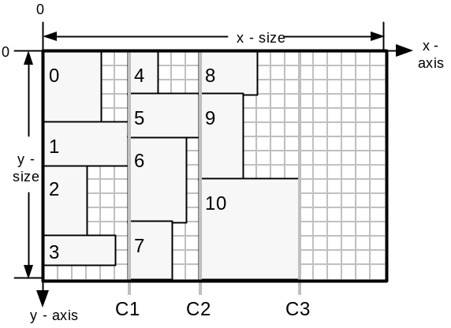
Figure 1.The layout of 11 items using the simple LDA. Annotation numbers signify order with which shapes were placed, beginning with zero. Column boundaries are labelled C1, C2 and C3. Column width is set by the widest shape in the column. The scale for all layout diagrams is a grid-square is one logical coordinate high and wide.

Terminology (Part 1)
Examples of how the terminology (italicised) is used to describe the relative positions of shapes throughout this project (referencing Figure 1):
- shape 0 is behind shapes 4 and 5
- shape 8 is in-front-of shape 4
- shape 4 is above shape 5
- shape 5 is below shape 4
- the placement position of shape 0 is (0,0) (Top-left vertex)
- the x-offset of shape 1 is 0 (x component of placement position)
- the y-offset of shape 4 is 0 (y component of placement position)
- the top- and bottom-faces of shape 0 are on the lines x=0 and x=5, respectively
- the left- and right-faces of shape 0 are on the lines y=0 and y=4
- the sheet has an area of x-size . y-size

In more advanced LDAs, heuristics are used to direct shape placement. A typical placement heuristic is to place a shape in the ‘leftmost’ area of the sheet which is entirely unoccupied by any previously placed shapes. A ‘topmost’ heuristic would operate in a similar way. A typical regime for placing shapes would be to alternate between these two heuristics, beginning with say ‘leftmost’.
Consider a regime where the ‘leftmost’ heuristic is always used. The sheet would get filled-up in a sweep from left to right, building in an approximate columnar arrangement from top to the bottom of the sheet. If there are two positions which are equally ‘leftmost’ then the LDA favours the position which is ‘topmost’ out of these two.
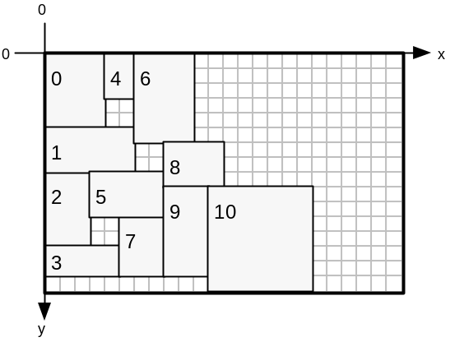
Figure 2. A greedy placement algorithm uses the ‘leftmost’ heuristic to layout the shapes used in Figure 1.
A regime which always uses ‘leftmost’ may favour placement of narrow, tall shapes. It may be biased against wide, short shapes due to the columnar construction of the layout. The same argument applies to a constant ‘topmost’ regime.

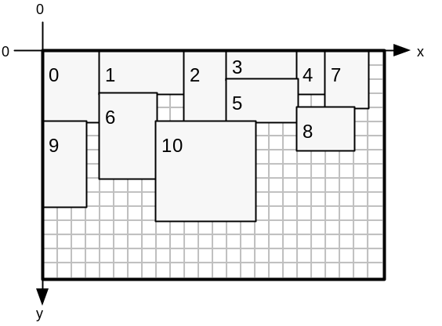
Figure 3. A greedy placement algorithm uses the ‘topmost’ heuristic to layout the shapes used in Figure 1.
Alternating the regime favours neither row or column building, so may be more capable of searching a large search space.

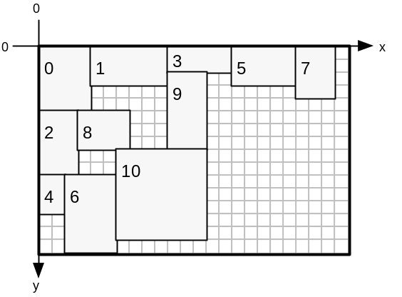
Figure 4: A greedy placement algorithm alternates between leftmost and topmost heuristics, beginning with leftmost, to layout the shapes used in Figure 1
Alternatively, a refinement to flipping between ‘leftmost’ and ‘topmost’ would be to store a heuristic inside every shape_gene. The LDA would then extract the heuristic setting from the shape_gene before placing the corresponding shape. The chromosome would then have three methods of diversifying:

- Exploring permutations of shape_genes
- Manipulating the orientation flag of each shape_gene
- Manipulating the placement heuristic of each shape_gene

To summarise, the simplest placement regime is to place all shapes ‘leftmost’ or ‘topmost’. This may be refined to alternating the heuristic between ‘leftmost’ and ‘topmost’, providing a more balanced placement mechanism. This may be further refined by allowing individual shape_genes to dictate individual placement heuristic, enabling the GA to evolve its own arbitrary placement regime. An example regime consisting of five shapes may be: left, top, top, left, top.

LDA Features
The LDA’s purpose is to make the search-space of possible layouts smaller. Erroneous layouts with overlapping shapes are eliminated from the search-space by using the LDA. This makes the GA more likely to find a good optimisation. Without the LDA, the GA would initially create random locations, in 2-dimensions, for the shapes. Overlapping shapes would be inevitable and layouts with at least one pair of overlapping shapes would form the majority of the search-space. Layouts with zero overlapping pairs would be sparsely scattered throughout the search-space, resulting in unfeasible conditions for evolving a good solution.

The LDA developed keeps track of the convex area encompassing free-space on a sheet. Placing a shape involves the LDA searching for sufficiently sized gaps in free-space in which the shape may fit. A choice is then made as to which gap to use, directed by the placement heuristic. A record of currently placed shapes and their locations is kept, whilst the free-space representation is updated on each placement. The LDA places all shapes in the order described by a chromosome, and subsequently calculates fitness metrics for the layout. These are then used to direct selection operators in the GA. The use of an LDA reduces the optimisation from a 2-dimensional problem to a 1-dimensional permutation-based one.

The LDAs designed for this project have the following features:
- Layout: A record of which shapes have been placed where on the sheet. Allows the entire layout to be examined once all shape_genes in a chromosome have been placed.
- Free-Space Representation: A representation of free space in the current sheet where new shapes may be placed.
- Placement Builder: An analyser for (2) which yields all possible placement positions for a particular shape.
- Placement Chooser: Picks a single placement position from (3) which satisifies the current placement heuristic, say ‘leftmost’.
- Free-Space Updater: Adjusts (2) to take account of a newly placed shape.
- Layout Updater: For adding the shape and its location to (1)
- Sheet Creator: Processes the situation where the current sheet has insufficient space to place the next shape, in where (3) yields no placement positions.
- Fitness Evaluator: Returns fitness value for the current layout corresponding to how efficiently sheets are used. This is calculated by considering the final state of (2) after all shape_genes in the LDA_chromosome have been placed.

LDA Design and Implementation of Features

- Layout: A record of which shapes have been placed where on the sheet. This allows the complete layout to be analysed after all shape_genes in a chromosome have been processed.

To satisfy this, an array of ‘layout_pieces’ is used. A single layout_piece contains:
- a copy of the shape_gene enhanced with an (x,y) placement coordinate, encapsulated into a shape_gene_l object
- a boolean (new_sheet_needed) which is true if the layout_piece requires a new blank sheet to be used.

The first element in the layout_piece array always has its boolean set to true. If all shapes in the chromosome have been placed onto a single sheet then all other layout pieces in the array have their booleans set to false. If the xth layout_piece cannot fit on the current sheet its boolean is set to true and an additional sheet is created for placement of the xth shape and any other unplaced shapes. As many sheets as are required are created as each sheet becomes full. Layout_pieces which fit on the current sheet have their boolean set to false.

- Free-Space Representation: A representation of free space in the current sheet where new shapes may be placed.

Firstly, we shall consider a representation which can work with the leftmost heuristic. The free-space representation trades-off completeness against computational complexity, and is required only to describe a ‘good’ proportion of the free-space available for new shapes.
Figure 5 illustrates a representation for free space. All shapes have been placed using the leftmost heuristic.
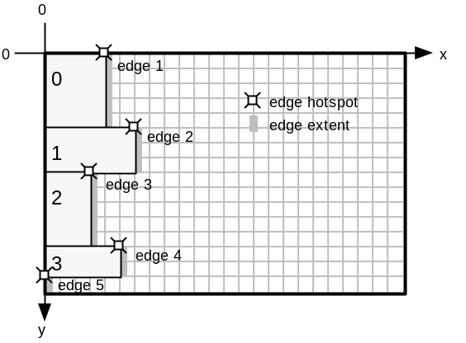
Figure 5. A representation for describing a convex outline of the free space remaining on the sheet.
An ‘edge’ exists wherever a shape has a segment of its right-face in line-of-sight (in a direction along the x-axis) with the right-face of the sheet. Each edge has a length (equal to the segment length) and an (x,y) coordinate corresponding to the edge’s upper-extent, known as the hotspot – marked with ‘’ in the diagram. Edges are stored in a linked list of edge nodes where nodes are ordered according to increasing y location of hotspot, y-edge-offset. This edge list is know as the left-profile. The left-profile maintains the list of edges which define the left-most limit of the free space available on the sheet. No two edges may overlap in the y-axis, and the left-profile represents the entire extent of the y-axis without discontinuity. The total length of all edges in the edge list is equal to the height of the sheet (the y-size of the sheet).
Figure 6 illustrates how both the current layout and the left-profile is updated as each shape is added to the layout, using a leftmost placement heuristic.

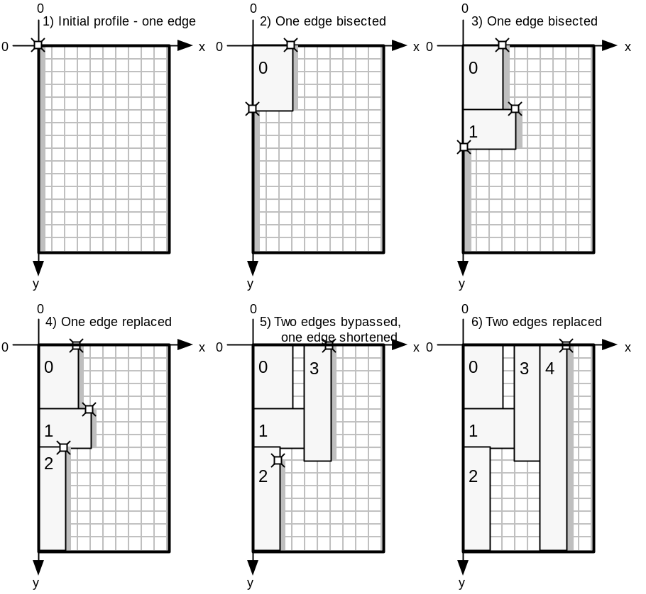
Figure 6. Layout construction and left-profile update illustration. In step 1, no shapes have been placed yet and there is one edge (hotspot=(0,0); length=y-size). Adding shape 0 and shape 1 both result in a single edge being bisected. Adding shape 2 results in an edge having its x location of hotspot, its x-edge-offset, increased by the width of the placed shape. Adding shape 3 bypasses edges 1 (top edge) and 2, whilst displacing and shortening edge 3. Adding shape 4 bypasses both remaining edges with a single edge equal in length to sheet y-size.

Limitations of the left-profile
The left-profile is good for placing shapes using the leftmost heuristic. However, when using a topmost heuristic areas of free-space are masked, making them unavailable for placement. Figure 7 shows how successively top-placed shapes mask areas behind the left-profile.
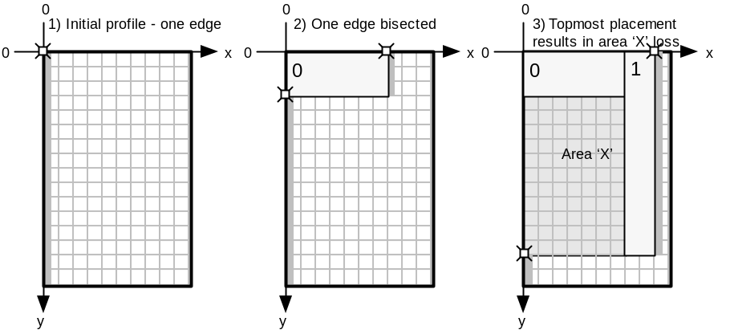
Figure 7. The addition of shape (1) in step (3) renders area ‘X’ invisible to the left-profile.This area is lost from the free-space representation. Invisible areas make it harder for the LDA to create efficient layouts. Free-space is masked from the left-profile when there is a shape to the right of the free-space.

Overcoming left-profile limitations – introducing the top-profile
The top-profile is a method by which free-space may be represented more effectively when used in-conjunction with a left-profile. Figure 8 illustrates the top-profile representation. All shapes have been placed using the topmost heuristic.
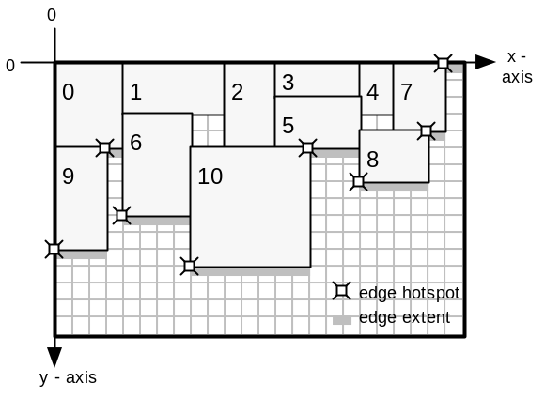
Figure 8. Top-profile is equivalent to left-profile rotated through 90 degrees. An edge hotspot corresponds to the left-extent of the corresponding edge, and edge length is measured in the x-axis. Edges are ordered according to increasing x-edge-offset in the top profile. The top-profile defines the topmost limit of the free space available on the sheet and considers the positioning of the bottom-faces of placed shapes. This is in contrast to the left-profile, which considers right-face positioning. The total length of all edges in the top profile edge list is equal to the width of the sheet (the x-size of the sheet). Before any shapes are placed, the top profile consists of a single edge (hotspot=(0,0); length=x-size), which spans the x-axis.

Top-profile is good for placing shapes using the topmost heuristic alone. Using the leftmost heuristic, with the top-profile representation, results in area masking as illustrated in Figure 9.
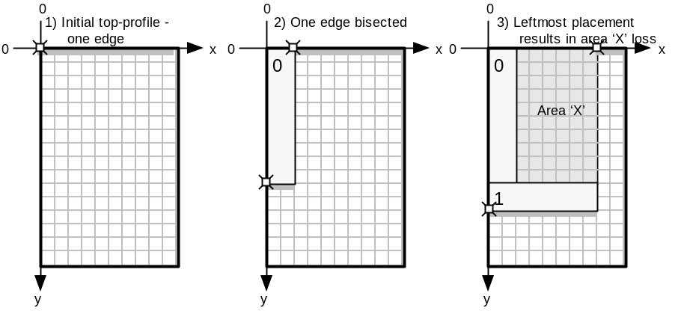
Figure 9. The addition of shape (1) in step (3) renders area ‘X’ invisible to the top-profile. This area is lost from the free-space representation. Invisible areas make it harder for the LDA to create efficient layouts. Free-space is masked from the top-profile when there is a shape below the free-space.
Once an area becomes masked it is no longer represented by any of the edge profiles. This restricts the number of places that the LDA can fit shapes. Although the space may be free, when masked from all profiles it cannot be utilised, so it is wasted reducing fitness.

Combining both left- and top-profiles
By using both a left-profile and a top-profile (independent of each other), a free-space representation better than either of these methods alone is possible. Using this dual-representation allows the previously masked ‘X’ areas in both Figure 7 and Figure 9 to be represented as free-space. When using the left-profile alone, free-space is masked when there is a shape to the right of the free-space. Similarly, when using the top-profile alone, free-space is masked when there is a shape below the free-space. The advantage of using the dual-representation is that only the free-space that has both a shape to its right and a shape below becomes masked. Figure 10 (parts (a) and (b)) shows how the final layouts in Figure 7 and Figure 9 are represented using two profiles – the shaded areas are no longer masked. Part (c) of Figure 10 illustrates the limiting case where a free-space area has both a shape to its right and a shape below it.
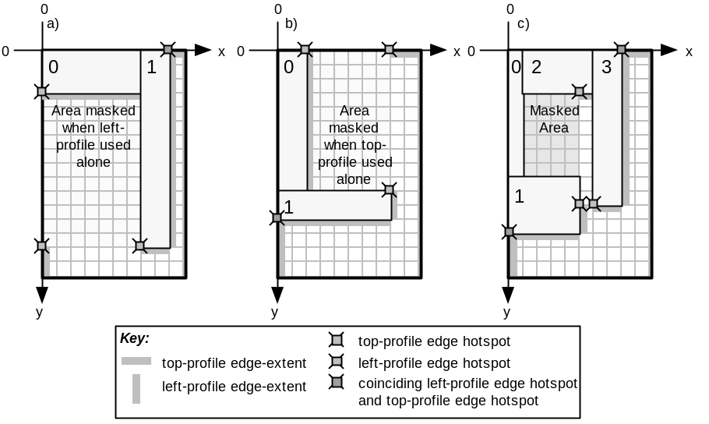
Figure 10. (a) Layout from Figure 7, step (3). The dual-representation prevents the shaded area from being masked, whereas it is in the left-profile only case. (b) Layout from Figure 9, step (3). The dual-representation prevents the shaded area from being masked, whereas it is in the top-profile only case. (c) This layout has been placed using a top-left heuristic, beginning with topmost, and illustrates the limitation of the dual-representation. The masked area cannot be represented by either the left-profile or the top-profile and so is unavailable free-space.
It is thought only a complete constrained-polygonal representation can improve upon the dual-representation. The ‘constrained’ aspect is because the polygon is composed of lines parallel to an axis. This representation would be considerably more complex and so we return to the completeness against complexity tradeoff that exists when designing the free-space representation. A constrained-polygonal representation would not use the profile concept at all and would treat the limiting case, as in Figure 10(c), as a single polygonal area – see Figure 11.
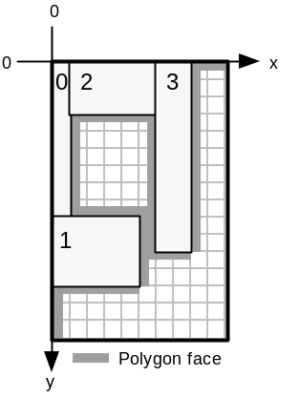
Figure 11.A polygonal representation of free-space. Placing a shape would require testing each polygon vertex and then checking if other vertices interfere with the shape placement.

The advantage of this representation is that any ‘holes’ (free-space completely surrounded by placed shapes) developed in the layout can be represented as additional constrained-polygonal free-space areas. There is no method to make holes in the single- or dual-representations available for shape placement. It is the job of the GA to fill holes by evolving a suitable permutation which prevented hole creation in the first place.

To conclude this section, the dual-representation has been chosen as it allows a fairly complete representation of free-space, without being overly complex.

Comparison of algorithms between left- and top-profile functions
Manipulating the top-profile requires the same algorithms as for the left-profile, except all references to a particular axis are switched to the opposite axis. The parallel axis refers to the axis parallel to the direction of an edge in a profile. The orthogonal axis refers to the axis orthogonal to the direction of an edge in a profile. Algorithms may be coded in terms of operations working with parallel and orthogonal axes, allowing them to work with both left- and top-profile, given appropriate initial settings according to the profile being manipulated. The differences are summarised in Table 1.

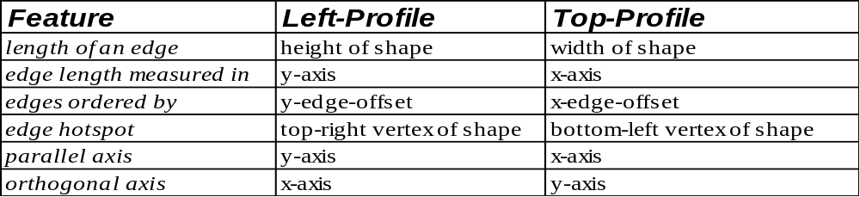
Table 1. Differences between left-profile and top-profile.

The parallel/orthogonal axis terminology is good for coding the algorithms, but is not convenient for describing the algorithms. The code proves that the algorithms for both profiles are the same, except for the initialisation stage where the meanings of parallel and orthogonal axis are set according to the profile being updated. The algorithms are described for the left-profile only, using the appropriate x/y axis terminology, to provide clarity.

Terminology (Part 2)
For left-profile:
- an edge corresponds to the right-face of a shape
- the edge hotspot describes the location of the upper-extent of a left-profile edge
For top-profile:
- an edge corresponds to the bottom-face of a shape
- the edge hotspot describes the location of the left-extent of a top-profile edge.
For both profiles:
- the y-edge-offset of an edge corresponds to the y component of the edge hotspot
- the x-edge-offset of an edge corresponds to the x component of the edge hotspot
- the parallel axis is the axis which is parallel to edges in the profile
- the orthogonal axis is the axis which is orthogonal to edges in the profile

- Placement Builder: An analyser for (2) which yields all possible placement positions for a particular shape.

All locations in the left-profile where a single new shape can be placed without overlapping existing shapes in the layout and without overlapping the edges of the sheet are placed into an array of coordinates called left-places. Locations found in the top-profile are added to the top-places coordinate array. The algorithm below is for extracting locations from the left-profile.

FOR all edges (n) in the profile:
LET current_edge=edge_n
LET accumulated_length=current_edge.length
LET fit_location=current_edge.hotspot
label1:
IF new_shape.height > accumulated_length THEN
IF (current_edge+1).hotspot.x > fit_location.x THEN
LET fit_location.x = current_edge.hotspot.x
SET current edge to next edge in profile
INCREASE accumulated_length by current_edge.length
GOTO label1
ELSE
IF fit_location.x + new_shape.width < sheet.width
Add fit_location to left_places array

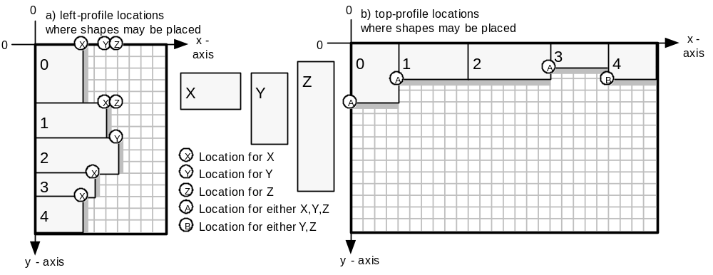
Figure 12. Locations to place shapes X, Y or Z in two layouts, where (a) shows locations derived from a left-profile; and (b) shows locations derived from a top-profile. All locations correspond to the positioning of the top-left vertex of the placed shape.
- Placement Chooser: Picks a single placement position from (3) which satisifies the current placement heuristic, say ‘leftmost’.

The locations stored in left_places and top_places are considered, and a single location which satisfies the current placement heuristic is picked.

If the shape is to be placed leftmost, then all locations in left_places and only the first location in top_places are considered. The location found with smallest x-offset is picked. If there are two or more locations with equally small x-offset, the location with smallest y-offset is picked. (i)

If the shape is to be placed topmost, then all locations in top_places and only the first location in left_places are considered. The location found with smallest y-offset is picked. If there are two or more locations with equally small y-offset, the location with smallest x-offset is picked. (ii)

The reason for considering only the first location in top_places for (i) is that locations in top_places are added to the array (part (3)) in the order in which they have been found in the top-profile. The top-profile is searched from its head, which is the edge leftmost in the top-profile (this is the edge with smallest x-offset).

The reciprocal argument is true for (ii) where only the first element of left_places is considered.

Figure 13 shows how a series of shapes has been placed using a left-top placement regime. Shape 0 is placed leftmost, shape 1 – topmost, shape 2 – leftmost, and so on. Shape 8 is the next shape to be placed. Edge profiles are shown, and edge hotspots have been omitted for clarity.

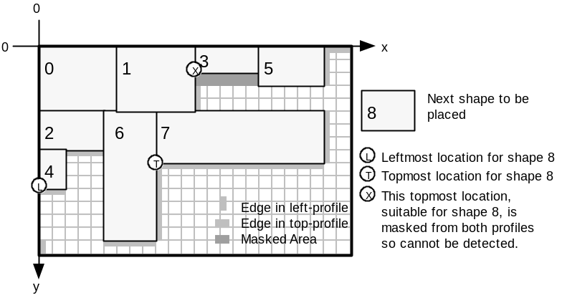
Figure 13. Shapes 0-7 have been placed using a left-top placement regime, beginning with the leftmost heuristic. Shape 8 is the next shape to be placed. Topmost and leftmost locations are labelled. The masked area is unusable as it has a shape to the right and a shape below it, rendering the area ‘invisible’ to both profiles. Loss of location X is an example of the limitations of the dual-representation.

- Free-Space Updater: Adjusts (2) to take account of a newly placed shape.

Once a place has been chosen for the shape, both left- and top-profiles are updated to account for the revised layout. The algorithm deals with four scenarios:
- Update left-profile using the right-face of new shape - location chosen from left_places
- Update left-profile using the right-face of new shape - location chosen from top_places
- Update top-profile using the bottom-face of new shape - location chosen from left_places
- Update top-profile using the bottom-face of new shape - location chosen from top_places

In cases (a) and (d) the chosen location has its x-offset and y-offset corresponding to either: the x-edge-offset and y-edge-offset of a single edge hotspot (as typified by the ‘X’ shape locations in Figure 12); or the x-edge-offset of one edge hotspot and the y-edge-offset of a different edge hotspot (as typified by the ‘Z’ shape locations in Figure 12).

In cases (b) and (c) the chosen location does not correspond to hotspot locations in the corresponding edge profile. This is because the profile from which we have derived the placement position is not the same as the profile we are updating.

Cases (b) and (d) are now examined as an example where both profiles are updated. Figure 14 (a) shows a current layout and the states of both left- and top-profiles. Consider (b.i), where shape 3a has been added to the layout using a topmost heuristic. The placement chooser returns the position marked with a circle.

We shall firstly consider case (b) – updating the left-profile. Notice that a part of the right-face of shape 3a is masked behind shape 1 and so does not affect the top edge in the left-profile. Part of 3a juts out below the bottom-extent of this edge and affects the second edge in the left-profile, whilst also creating a new edge. In (b.ii) shape 3b has been added to the original layout using a topmost heuristic. This time the new shape is completely masked behind shape 1 and so no changes need to be made to the left-profile.

The top-profile is easier to update (case (d)) because the placement position coincides with the hotspot of the second edge in the top-profile. Updates (b.i) and (b.ii) are equivalent problems for updating the top-profile, where a single edge in the top-profile is bisected.
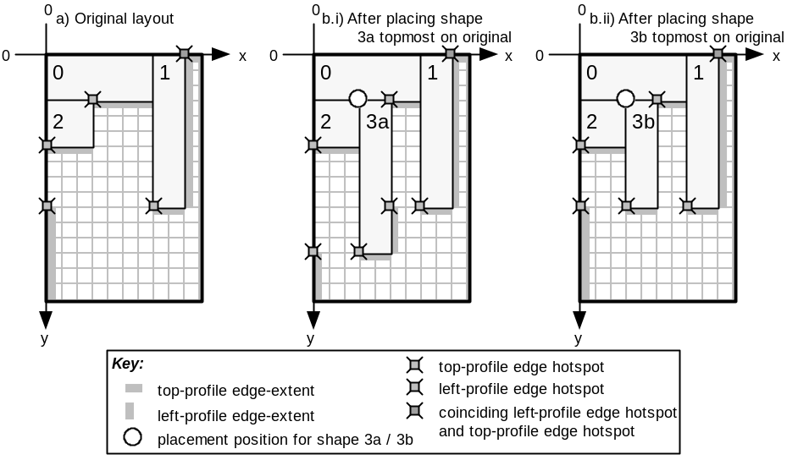
Figure 14. Update scenarios for both left- and top-profiles. (a) A snapshot of the original layout; (b) The layout after adding shape 3a to the original layout; (c) The layout after adding shape 3b to the original layout
These are the types of scenario which the update algorithm has to deal with. Cases (a) through (d) are not explicitly distinguished in the algorithm, but they are all accounted for implicitly. The algorithm was originally written explicitly dealing with the different cases, but the algorithm was found to degenerate into the more elegant solution proposed below.

The algorithm described outlines how the left-profile is updated. The top-profile is updated using the same algorithm, with the necessary changes outlined in Table 1. Below is a list of operations which are carried out by the algorithm. Steps (i-vi) are always executed. Steps (vii-x) are not executed if the new shape is invisible to the left-profile.

- Create a new edge to represent the shape to be added to the layout.
- Find out if any edges in the left-profile connect exactly with the new edge.
- Find the first-edge in the left-profile that might by affected by new edge inclusion.
- Calculate some values.
- Find the start-edge which actually is the first edge to be affected and also find the last-edge-affected by the inclusion of the new edge.
- Check if new shape is invisible to left-profile – if so no update needed – exit algorithm.
- Delete all edges from start-edge to edge before last-edge-affected.
- Delete last-edge-affected if required.
- Adjust new edge hotspot and length if behind an existing edge.
- Integrate new edge into left-profile.

Each of these steps are detailed below:

- Create a new edge to represent the shape to be added to the layout.
The new edge is initialised accordingly:
edge-x-offset = x location of right-face of placed shape
edge-y-offset = y location of top-face of placed shape
length = height of placed shape

- Find out if any edges in the left-profile connect exactly with the new edge.
Scan the entire edge list to find out if the new edge abuts directly above and / or below any existing edges in the list. The first condition for abuttage is for the edge-x-offset of the existing edge and the new edge to be equal. Secondly, the existing and new edges must run contiguously in the y-axis.
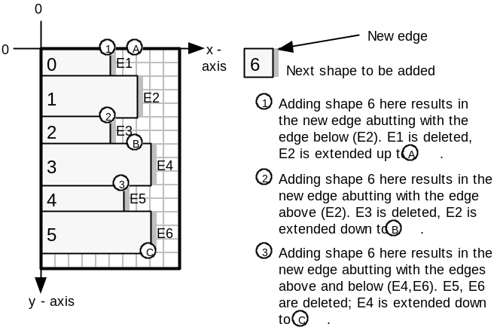
Figure 15. Diagram showing the three types of abutting which can occur when the left-profile is updated.

The following_edge pointer is set to point to any existing edge which abuts below the new edge. The previous-edge pointer is set to point to any existing edge which abuts above the new edge. In the case where there are no abutting edges, these pointers are set to NULL.

- Find the first-edge in the left-profile that might by affected by new edge inclusion.
Scan the edge list to find the edge which is horizontally in line with the top face of the new edge. Store a pointer to this edge in both first-edge and start-edge pointers. Figure 16 gives an example.
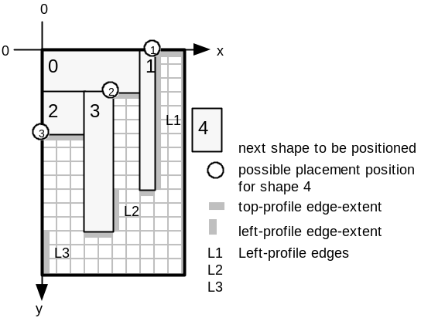
Figure 16. Placing shape 4 at any of the circle locations results in first-edge and start-edge being set to L1.

- Calculate some values.
start-offset stores the difference in y-edge-offset between the top of the new shape and the top of the first-edge. This value is 0 for position (1) in Figure 16, 3 for position (2) and 6 for position (3).
accumulated-edge is a distance which is measured starting from the hotspot of first-edge in an increasing y-axis direction. It is used when progressing through the edge profile to find out which edges are affected by the new shape being added and in particular which edge is inline with the bottom-face of the new shape (the last-edge-affected).
The accumulated-edge value is initially set to such a value that results in accumulated-edge equalling the distance between the top-face of the new shape and the bottom-extent of the first-edge (measured in the y-axis direction), after the length of the first-edge has been added to the initial accumulated-edge value. Thus, accumulated-edge is initially set to negative start-offset.

- Find the start-edge which actually is the first edge to be affected and also find the last-edge-affected by the inclusion of the new edge.
Setting start-edge to an edge other than first-edge is necessary when the new shape juts out from behind edges in the profile, as shape 3a does in Figure 14(b.i). In the original layout of Figure 14(a) when considering the placement of shape 3a, first-edge is set to the top edge in the left-profile, whilst start-edge is the second edge in the left-profile. The last-edge-affected is also the second edge in the left-profile in Figure 14(a). The algorithm for setting start-edge and last-edge-affected follows:

Initially, SET n to first-edge.
label_1:
Add the length of the nth edge to accumulated-edge and store the result in accumulated-edge. IF new edge has an x-edge-offset less than edge n (ie new edge is behind edge n), set start-edge to point to edge n+1 (the next edge after n in the edge list).
IF accumulated-edge < height of the new shape, GOTO label_1 after setting n to n+1
ELSE SET the last-edge-affected pointer to edge n.

- Check if new shape is invisible to left-profile – if so no update needed and exit the algorithm.
If the hotspot of new edge is behind the hotspot of the last-edge-affected, AND if the bottom edge of the new shape is above the lowest reach of the last-edge-affected, then the new shape is ‘invisible’ to the left profile – so no changes to the left profile are required and we can exit this algorithm. See Figure 14(b.ii) for an example where the new shape is invisible to the left-profile.

- Delete all edges from start-edge to edge before last-edge-affected.
Delete all edges beginning with start-edge, up to, but not including, last-edge-affected. This removes any edges bypassed by the new edge. Also set remaining value to accumulated-edge minus new shape height. (remaining is equal to the length of the last-edge-affected that is not overlapped by the new edge. See Figure 14(b.i) where the length of the bottom edge in the left-profile corresponds to this remaining value.)

- Delete last-edge-affected if required.
IF the remaining value is zero, delete the last-edge-affected from the edge list, as the last edge is completely overlapped by the new edge.
ELSE move the hotspot of the last-edge-affected such that last-edge-affected abuts below the new edge and reduce the length of last_edge_affected to equal remaining value (See Figure 14(b.i) where the bottom edge in the left-profile is created in this way.)

- Adjust new edge hotspot and length if behind an existing edge.
If the new edge hotspot is behind the first edge hotspot then move the new edge hotspot down, such that the new edge is inline with the top-extent of start-edge. Next, reduce the new edge length by the amount the hotspot moved. See Figure 14(b.i) where the new edge in the left-profile, due to shape 3a, is not as long as shape 3a is high. Also, the edge-y-offset of the new edge has been shifted to be in line with the top-extent of the start-edge.

- Integrate new edge into left-profile.
If there is no abutting to do above or below the new edge then add the new edge to the edge list keeping the edge list ordered on increasing y-edge-offset.

(See Figure 15 to see how the abutting process merges existing edges with the new edge.)

OTHERWISE:
If abutting occurs only with following-edge (ie below new edge), set the following-edge hotspot to coincide with the new edge hotspot, then add the length of the new edge to the following- edge length, storing the result.
OTHERWISE:
If abutting occurs only with previous-edge (ie above new edge), increase previous-edge length by new edge length.
OTHERWISE:
If abutting occurs both above and below the new edge, increase previous-edge length by the sum of new edge length and following-edge length. Remove the following-edge from the edge list.

This completes the design and implementation of part (v), the Free-Space Updater, of the LDA features. The remaining LDA features are discussed below.

- Layout Updater: For adding the shape and its location to (1)
Once a location has been chosen for the new shape, the shape along with its location and a flag indicating whether a new sheet is required is encapsulated inside a layout_piece and is added to the layout_piece array. The layout_piece array is used to recover coordinates for all shapes after the entire layout has been arranged.

- Sheet Creator: Processes the situation where the current sheet has insufficient space to place the next shape, in where (3) yields no placement positions.
When no placement positions are available for the new shape, a new, empty sheet is used to accommodate this shape and any remaining unplaced shapes. If this new sheet itself becomes full, then another sheet is created. This is a recursive process which generates as many sheets as are required to lay out the permutation described in the current chromosome. All sheets are made to the same (x-size,y-size) dimensions.

- Fitness Evaluator: Returns fitness value for the current layout corresponding to how efficiently sheets are used. This is calculated by considering the final state of (2) after all shape_genes in the LDA_chromosome have been placed.

The fitness evaluator has to provide a simple metric by which we can evaluate the quality of a layout, and thus the quality of a chromosome. A floating point number in the range 0 to 1 is ideal. There is a two stage process to generate this fitness metric.

Firstly, all sheets required to lay out the permutation described in the chromosome being evaluated are analysed. Upon finishing with a full sheet and also where the layout is completed, the area used on this sheet is evaluated and is stored in a fitness-report. After all shapes have been laid out, the fitness-report contains separate area data for each sheet used in the layout.

The area used in each sheet is calculated by dropping a perpendicular line coinciding with the rightmost edge in sheet’s left-profile, leaving a rectangular free-space area to the right. This free-space is considered ‘good-scrap’ as it may be suitable for reuse. The rectangular area to the left of the perpendicular line is deemed to be the sheet-usage area. Figure 17 illustrates an example of what is included in the sheet-usage area.

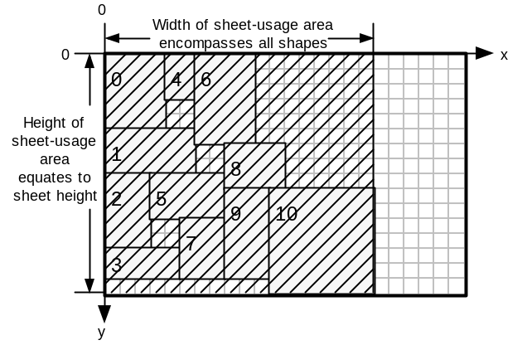
Figure 17. The hatched area represents sheet-usage area for this sheet.

Once all sheet-usage areas are available, an overall-usage function considers:
- the total sheet-usage area for all sheets (total-used-area)
- the total area of all shapes in the layout (min-achievable-area)
- the number of sheets used by the layout (actual-sheet-number)
- the minimum number of sheets that theoretically could contain all shapes.
(min-sheet-number)

actual-sheet-number is a floating-point number which represents number of sheets totally used, plus the fraction of the last sheet used. The calculations for overall-usage for a single layout spread over multiple sheets is below:

min-sheet-number = (min-achievable-area / single-sheet-area) * sheet-allowance
actual-sheet-number = sheets-used – 1 + area-used-in-last-sheet / single-sheet-area
area-quotient = min-achievable-area / total-used-area
penalty = 1 / (actual-sheet-number – min-sheet-number + 1 )

overall-usage = area-quotient * penalty

The penalty function weakens solutions that use more sheets than are reasonably expected to be required. The sheet-allowance scalar is included as we know that it is unreasonable to expect the min-sheet-number to be achieved. This is because min-sheet-number only takes into account the total area of all shapes and makes no allowance for the ease by which they can fit together. We may expect to get within a percentage of this value, say 30%, but this is dependent upon the variety of shapes being placed. sheet-allowance may be set to 1.33 in this case.

To conclude, overall-usage is ideally a floating-point number in the range 0 to 1, where 1 represents perfect fitness. Fitness greater than 1 occurs when the sheet-allowance has been set too high. The value of overall-usage is used as the fitness value for the entire layout. The GA uses this fitness value when selecting parent chromosomes for breeding.

